**Select:**

The SELECT statement is used to select data from a database.

The SQL SELECT Statement

The SELECT statement is used to select data from a database.

The result is stored in a result table, called the result-set.

SQL SELECT Syntax

SELECT *column_name*,*column_name*  
FROM *table_name*;

and

SELECT * FROM *table_name*;

**From:**

SQL: FROM CLAUSE

This SQL tutorial explains how to use the SQL FROM clause with syntax and examples.

DESCRIPTION

The SQL FROM clause is used to list the tables and any joins required for the SQL statement.

SYNTAX

The syntax for the FROM Clause in SQL is:

FROM table1

[ { INNER JOIN

| LEFT [OUTER] JOIN

| RIGHT [OUTER] JOIN

| FULL [OUTER] JOIN } table2

ON table1.column1 = table2.column1 ]

1. Fine the Eno., Ename of the Employee whose salary is greater than 4000.

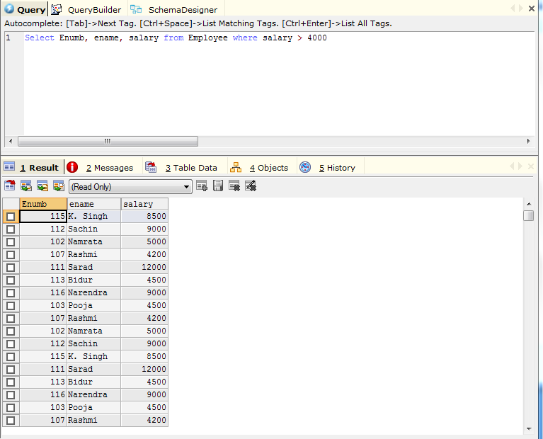

1. Find the Eno, Ename, Salary of the employee whose salary is greater than 5000 and job status is professor. 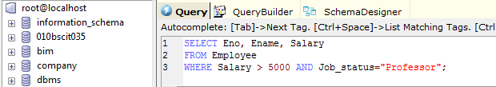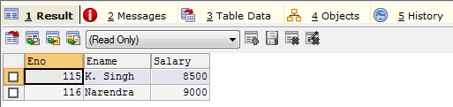
2. Find the eno, name, age and salary from the employee whose department number is 20 or job status research fellow.

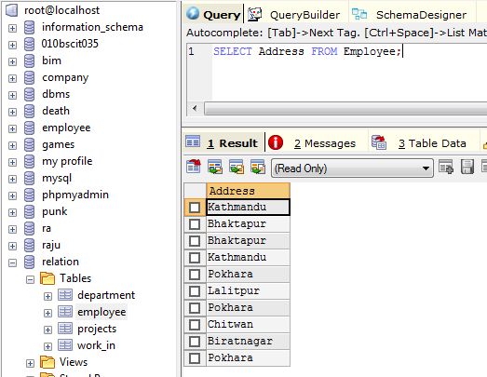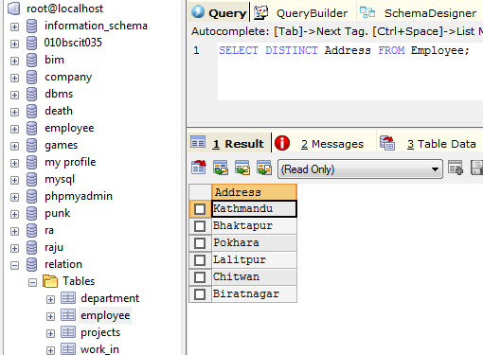

1. Find the Ename, age, and salary from the employee where the age is between 24 and 28
2. ‘ABC%’ = all string that start with abc
   1. Example abcd and abcabc who both satisfy the condition.
3. ‘%ABC’ = all string that end with abc.
4. ‘%an%= all string that contain the pattern *an* anywhere.
   1. Example angles, Kathmandu
5. Find the Ename Whose starting latter is *sa*.
6. List all Employee names With their project name.
7. List name of all employees and their salary who are working in Project Mars or Venus.
8. List Name of all employee and their salary who are working in project of earth and venus.
9. List name and address of all employee who works in department which is located in pokhera.